**Multi-threading VS Multi-Tasking (Async)**

**What is Multi-threading?**

Multi-threading is a ability of a program or an operating system to manage its use by more than one user at a time or even manage multiple requests by the users where each user request for program is kept track of as a thread with a separate identity. As programs work on behalf of the initial request for that thread and are interrupted by other requests, the status of work on behalf of that thread is kept track of until the work is completed.

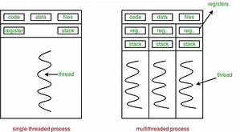

**What is Multi-tasking?**

It is also similar to multithreading, but Multitasking, in an operating system, is to allow a user to perform more than one computer task such as the operation of an application program at a time. The operating system is able to keep track of where you are in these tasks and go from one to the other without losing information. The Rust language provides first-class support for cooperative multitasking in form of async/await.

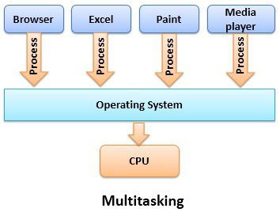

Using async/wait, we have basic support for cooperative multitasking (cooperative multitasking requires that the tasks voluntarily give up control of the CPU through a yield operation on a regular basis) in our kernel. While cooperative multitasking is very efficient, it leads to latency problems when individual tasks keep running for too long and thus prevent other tasks to run. For this reason, it makes sense to also add support for preemptive multitasking to our kernel.

// in src/main.rs

async fn async_number() -> u32 {

42

}

async fn example_task() {

let number = async_number().await;

println!("async number: {}", number);

}

**Comparing multithreading and multitasking:**

The most basic difference between multithreading and multitasking is that multithreading allows multiple threads of same process to execute simultaneously. Whereas, multitasking allow CPU to perform multiple tasks i.e. programs, process, task simultaneously.

|  |  |
| --- | --- |
| **multitasking** | **Multithreading** |
| Multitasking let CPU to execute multiple tasks at the same time. | Multithreading let CPU to execute multiple threads of a process simultaneously. |
| In multitasking CPU switches between programs frequently. | In multithreading CPU switches between the threads frequently. |
| In multitasking system has to allocate separate memory and resources to each program that CPU is executing. | In multithreading system has to allocate memory to a process, multiple threads of that process shares the same memory and resources allocated to the process. |